The innovation divide – new cooperative research published
Christian Reiner, senior researcher at LBS (http://lbs.ac.at/about/people/research/) published an essay on innovation economics on a blog for economic research, called “Ökonomenstimme” (http://www.oekonomenstimme.org/). Blogs have become an increasingly popular platform for discussing not only the latest research contributions and policy issues in economics but also in business studies. The blog “Ökonomenstimme” is arguably one of the most influential blogs for German speaking countries and widely read by researchers and the wider interested public alike. The article was co-authored by Christopher Kronenberg, Deputy Head of the Center for Strategy and Competitiveness, which is part of the Center for Corporate Governance and Business Ethics at the University of Applied Sciences for Management & Communication (http://www.ccgbe.at/christopher-kronenberg/).
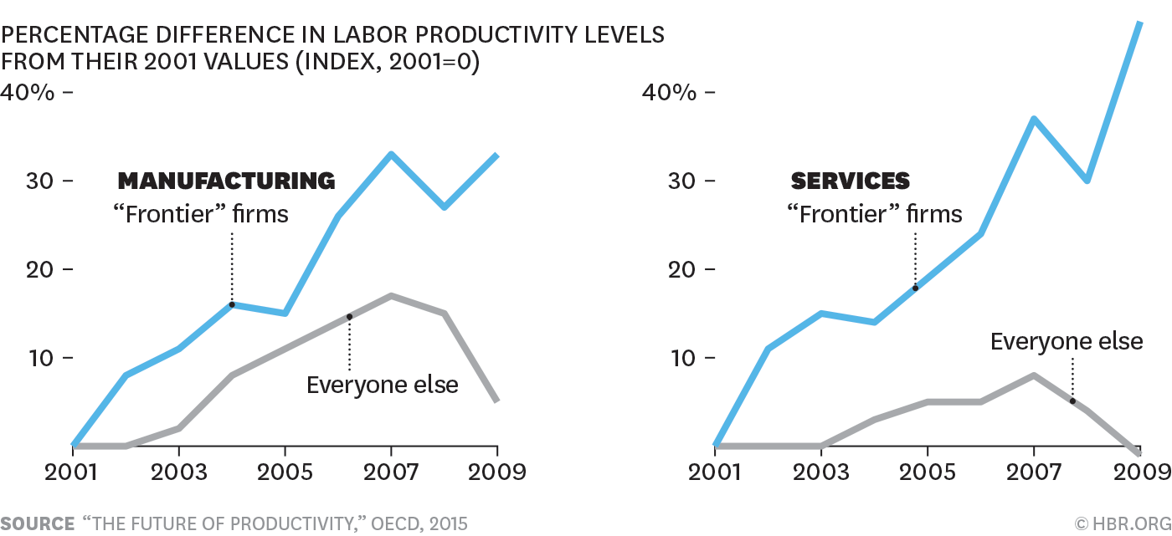
Innovation is one of the core activities for firms in order to increase competitiveness and market shares. Indeed, empirical studies reveal that innovative firms have a higher propensity to export, they grow faster and are more resilient in economic downturns. Yet new evidence points to potentially worrisome developments within the business sector. A relatively small share of firms is able to increase their productivities while the majority of the remaining firms fall behind. This observation concurs with a similar trend in innovation activities. In countries such as Germany or Switzerland innovation activities (as measured by innovation expenditures) are increasingly concentrated in large and already above-average innovative companies. This perplexing result points to lower levels of diffusion of innovations in the digital age where nothing appears easier than transmitting information about new products or business processes. Taking innovation as an important driver of productivity growth into account, the two divergent developments in terms of productivity and innovation are likely to be related.

See here for the article: http://www.oekonomenstimme.org/artikel/2018/04/die-innovationsluecke-zunehmende-divergenz-im-innovationsverhalten-von-firmen/

Christian Reiner, 18.04.2018

