New Special Issue published!
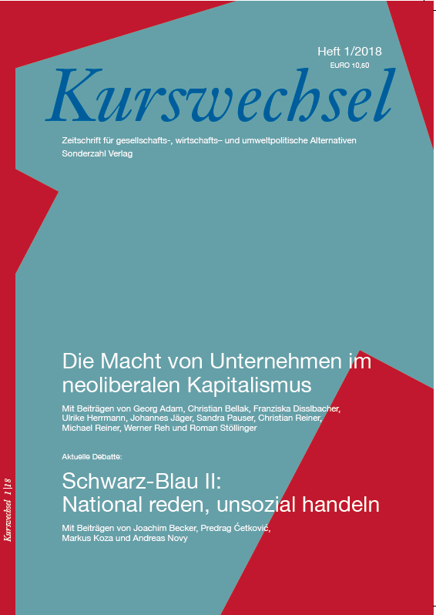
The rising power of firms is a major topic for economists and business scholars. While managers try to gain market power by applying several (legal and sometimes even illegal) strategies, society may suffer from welfare losses and higher inequality as a result. While these issues are more discussed in the US than in Europe, an increasing number of publications are devoted to the analysis of corporate power and its consequences within Europe.
Referring and contributing to this ongoing academic debate, Christian Reiner, senior researcher at LBS, has co-edited a special issue together with Christian Bellak, Professor at the Vienna University of Economics and Business (https://www.wu.ac.at/vw4/ma/bellak/). The special issue with the title “The power of firms in the age of neoliberal capitalism” is published as part of the journal “Kurswechsel”, an Austrian, German-speaking journal that takes a critical view on socio-economic developments in rich and poor countries (http://www.beigewum.at/kurswechsel/jahresprogramm-2018/heft-12018-die-macht-von-unternehmen-im-neoliberalen-kapitalismus/). The editorial (only in German) is available here (http://www.beigewum.at/wp-content/uploads/KuWe-1_18-Editorial.pdf).
The special issue contains contributions from researchers with different disciplinary backgrounds. For instance, Sandra Pauser (http://lbs.ac.at/study-programs/international-business-administration-bachelor/faculty/), lecturer in marketing at LBS, gives an overview on the strategies that firms apply to protect or expand their more or less powerful position in the market. Another contribution by the German economist Werner Reh (https://www.bund.net/ueber-uns/organisation/bundesgeschaeftsstelle/politik/) sheds light on the dense and probably harmful nexus between the German state and German automobile firms, which benefits the companies and their shareholders at the expense of consumers and the environment.
All in all, the papers provide quite an encompassing overview on several channels through which firms can exercise power to increase profits (power over customers, workers, suppliers or policy makers). Finally, the publication illustrates the high relevance, number and quality of research co-operations of the LBS research unit.

Christian Reiner, 27.06.2018

