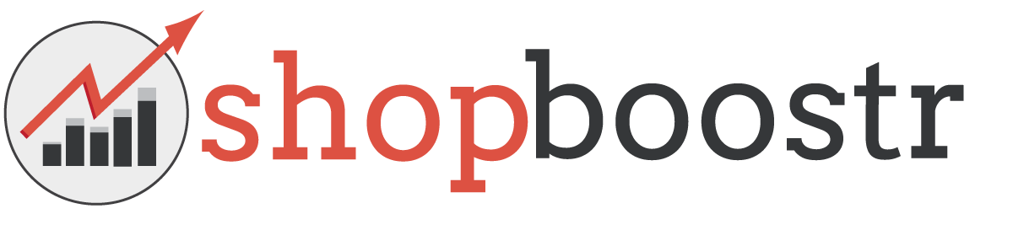
Shopboostr is looking for a Business Development Intern

EMPLOYER INFORMATION
Name of organization | Shopboostr
Address | Hardenbergstraße 38
Postal Code, City | 10623, Berlin
Country | Germany
Telephone | +49 176 8111 6417
E-mail | info@shopboostr.de
Website | www.shopboostr.de
Size of enterprise | Small
Year of foundation | 2014
Short Description of the Company | Headquartered in the centre of Berlin, Shopboostr is a spin-off of the Technical University Berlin. We help ecommerce retailers to increase their conversion rates and average order value through the use of big data and machine learning algorithms. Our SaaS solution is free to install, works with any ecommerce platform through a few code snippets and offers a performance based pricing model.  Together with university research and the support of the Telekom Innovation Labs we are developing a groundbreaking technology for multiple industries. We believe that through the use of big data and predictive algorithms we will be able to change the future of the ecommerce middle class.

CONTACT PERSON DETAILES
Name | Dimitri Haußmann
Department / Function | Co-founder & CEO
Direct telephone number | +49 176 8111 6417
Direct e-mail address | dimitri@shopboostr.de

PLACEMENT INFORMATION
Department / Function | Business Development Internship
Description of activities | We are looking for a Business Development Intern to join our team. You will work within the Business Development Department of Shopboostr to advance the market adoption of our SaaS product in the ecommerce field.  In this function you will work directly with our CEO, getting room and responsibility to drive your own projects. Within your role you will work on different product areas, based on your skillset: The acquisition/research of new clients, development and creation of sales material, adoption of new CRM tools, research of competitor/development of new focus areas...
Duration and Application | 3-6 months: starting in Q1 2015  Application deadline: 28.02.2015
Weekly working hours | 40h / week
City | Berlin
Help with finding accommodation | Yes

REQIUREMENTS
Who You Are | - Started a Bachelor/Master studies with the focus on business administration  - You enjoy the newest technologies, especially in the ecommerce/B2B field  - You gained first experience in the startup ecosystem  - You can structure your own projects and work independently  - First experience in Marketing/Sales or Business Development  - You are eager to work in a fast growing Startup
Language skills | English or/and German
Field of study | Business Administration or another rigorous discipline.
Your Personal Attributes | - You are a hand-on person have an entrepreneurial spirit  - Somebody who doesn´t accept the status quo, but wants to tweak, grow and improve constantly  - Good personal communication skills  - Fluent in English, both in writing and verbally  - We are looking for someone who has some sense of humor

